IdeAir: Internet of Things-Based System for Indoor Air Quality Control
Gleiston Guerrero-Ulloa^{1,2} [0000-0001-5990-2357], Alex Andrango-Catota¹ [0000-0002-0965-7522], Martín Abad-Alay¹ [0000-0002-4585-2878], Miguel J. Hornos² [0000-0001-5722-9816] and Carlos Rodríguez-Domínguez² [0000-0001-5626-3115]
¹ Faculty of Engineering Science, State Technical University of Quevedo, 120501 Los Ríos, Ecuador
{gguerrero, alex.andrango2016, martin.abad2016}@uteq.edu.ec
² Higher Technical School of Computer and Telecommunications Engineering,
University of Granada, 18071 Granada, Spain
gleiston@correo.ugr.es, (mhornos, carlosrodriguez}@ugr.es
Abstract. The burning of fossil fuels by cars and household appliances, which make people's lives easier, causes air quality to deteriorate. Fossil fuel-dependent water heaters and space heaters, which help low-income people live better lives, can kill them. Many solutions to this social problem have been proposed; however, all of them suffer from some drawback that makes their application impossible for households with limited financial resources. This paper proposes the design of IdeAir, a low-cost Internet of Things (IoT)-based air quality monitoring system that aims to reduce the disadvantages of existing systems. IdeAir captures data on harmful gases and determines their concentrations, issuing alarms and notifications based on their concentration levels. Its development was carried out following the Test Driven Development for IoT-Based Systems Methodology (TDDM4IoTS) which, together with the tool used (based on this methodology) for the automation of the development of IoT-based systems, has facilitated the work of the developers. Preliminary results on the functioning of IdeAir show a high level of acceptance by potential users.
Keywords: Internet of Things, Development Methodology, Development Tool, Microcontrollers, Air Quality.
- Introduction
Air quality is measured by the amount of toxic gases present in the environment. Gases, such as ozone (O₃) at the earth's surface, nitrogen dioxide (NO₂), carbon monoxide (CO), carbon dioxide (CO₂), ammonia (NH₃), sulphur dioxide (SO₂), benzene (C₆ H₆) and particulate matter (PM) are the main pollutants in the environment. These gases are produced by the burning of fossil fuels by vehicles, refineries, thermoelectric power generators, and industries [1], and even appliances used in the home, such as heaters to heat the environment and water for daily activities. These gases, above certain concentration levels, cause potential harm to human health, and in the worst cases, death. This is especially problematic in populations situated at high altitudes, where there is a low concentration of oxygen. Concern to prevent these pollution-related deaths worldwide has prompted the WHO (World Health Organisation) to update the indicators for air quality in order to improve this universal right [2].
Space heaters are used to condition the room temperature, and water heaters to heat the water in homes in cold climates. These appliances, being fuelled by fossil fuels, emit gases, such as CO, which, due to their characteristics (odourless, invisible, tasteless and non-irritating to the eyes), are hazardous [3]. In fact, CO is considered to be the silent killer. This problem, and the consequences of the possible misuse of heaters, have concerned several governments, such as those of Argentina [4] and Ecuador [5].
Health care costs due to air pollution reach $150 billion per year in the US [6]. Transportation is the main cause of CO2 air pollution [7]. In 2021, 70% of vehicles sold were fossil fuel vehicles [8]. Over the years, vehicles emit gases in greater proportion. In developing countries such as Ecuador, the useful life of private vehicles has no limit. Policies such as this one aggravates the problem of indoor pollution, since the inhabitants adapt garages as part of their homes, and the ignition of the cars can pollute the interior of the houses. The act of parking a vehicle can pollute the environment [9], in this case the indoor environment of homes.
New technologies such as IoT and cloud processing are aimed at providing people with a healthier life. these technologies have given rise to new domains such as smart homes, smart cities, to name a few [10]. Among the benefits that these new domains bring to people are a comfortable and healthy life, thus improving their lifestyle.
Bommi et al. [11] propose a very important solution to monitor and try to solve the pollution problem. However, due to the investment required, it would not be feasible to implement it in households using space heaters. Another work on air quality monitoring is presented by Zhou et al. [12] who present a system that issues messages to the user when pollution levels exceed thresholds. In addition, to prevent a serious event, the system can turn on a fan, which would clearly be insufficient in an enclosed space, such as inside a house.
As a contribution to reduce the number of people suffering from poisoning by hazardous gases, such as CO, CO₂, NO₂, NH₃ and C₆ H₆, this paper proposes an Internet of Things (IoT)-based system (IoTS) that is able to detect these gases indoors and make appropriate decisions. It can therefore be seen as a system for maintaining ideal air, hence its name: IdeAir. After its implementation, a technical demonstration of its execution was carried out in the city of Quito, the capital of Ecuador, which has a cold climate and is located at 2850 metres above sea level, where there have been several deaths due to problems with heating systems [13].
The main motivation for the development of this IoTS is to provide a reliable solution with a feasible and low-cost implementation to address the social problem described above. Another motivation is to perform an initial validation of the development methodology proposed by Guerrero-Ulloa et al. [14] as it is a new methodology, and one of the few methodologies specifically designed for IoTS development.
The remainder of this document is organised as follows: Section 2 presents the related work. The section 3 describes the proposed system, as well as the development methodology followed, and the results obtained by applying each of the phases of this methodology. Finally, the section 4 section summarises the conclusions and future work.
- Related work
The world is concerned about air pollution and its fatal consequences. This is reflected in the fact that the WHO has issued new guidelines for controlling air pollution, considering particulate matter (PM) from 2.5µm size upwards [2]. Moreover, the scientific community has presented some work to help alleviate the consequences of air pollution and improve air quality.
Considering that vulnerable people often spend a lot of time in indoor environments, where contamination is higher than in outdoor environments [15] solutions have been presented for these spaces. Bommi et al. [11] aim to control air pollution by reducing the toxicity of gases produced by combustion through a physico-chemical process that generates oxygen.
In the line of pollution monitoring, one can consider the work of Liu, et al. [16] which consists of monitoring CO2 and PM2.5, among other parameters. In the field of pollutant monitoring there is also AirSensEUR, which consists of a plug-and-play interoperable sensor node, designed as an open multisensor platform whose investment is around 1000 euros [17].
Taştan & Gökozan [18] propose e-nose, a mobile real-time air quality monitoring system. It is enabled to measure various air parameters, such as CO2, CO, NO2, PM10, temperature and humidity. However, the only way to alert the user about dangerous pollution levels is through notifications sent to the mobile application. Another work is that of Azma et al [19] which provides air quality readings using low-cost sensors.
Although all the works reviewed provide solutions to help prevent people from environmental conditions harmful to their health, each of them has some characteristic that makes it impractical to be implemented in low-income households. In the case of the systems presented respectively by Bommi et al. [11] and by Liu et al. [16] their main disadvantage is the high investment required. In addition, the laser used to obtain oxygen in the first one has to be activated manually when the CO value exceeds a threshold value, while the second system is intended for smart buildings. On the other hand, the analysed systems, except for Bommi et al. [11] do not have adequate mechanisms to try to improve air quality. Another disadvantage of all the reviewed works [11, 16–19] is the limitation of the means in which the notifications are reproduced, as they are only reproduced through the mobile application. In the system proposed by Azma et al. [19], sending notifications via email is not very effective in emergency situations.
As an attempt to counteract the disadvantages of the aforementioned systems, we have designed and developed a proof-of-concept IdeAir, which is a low-cost IoTS. IdeAir consists of: (1) a device to be deployed inside the home to detect and control the pollution, in addition to reproduce alerts, (2) a mobile application for configuring the device, viewing real-time data and receiving alerts on pollution levels, and (3) a web application that, in addition to having the same functions as the mobile application, serves to visualise reports of the data captured by the system and additional information from IdeAir. Although new and modern buildings are equipped with wireless communications technologies [6], most of the buildings from previous years have been adapted to achieve the same objective. IdeAir intends to take advantage of this functionality.
- Proposed system
The proposed IdeAir system, in addition to providing information on air quality levels, alerts users in many ways, depending on the detected air pollution levels. For this work, four levels of CO have been considered to determine air quality, as shown in Table 1. In addition, for each level, the system displays the corresponding message on its LCD screen.
Table 1. Air quality levels.
Level | Quality | Concentration (ppm) | Notifications (light) | Actions
1 | Good | ≤ 350 | Green | No sound and no performance.
2 | Moderate | (350, 500] | Blue | Intermittent beeping sound.
3 | Baja | (500, 800] | Orange | Medium and constant sound,  opens the window.
4 | Mala | > 800 | Red | Loud and constant sound,  opens the window,  switch on the fan,  notification in the mobile app.
As shown in the Table 1, a concentration above 800ppm has been considered the most dangerous. Particulate matter is considered the direct cause of respiratory diseases in humans [6]. The table also shows the alerts and actions that have been implemented in IdeAir for the four air quality levels considered.
IdeAir is an IoTS developed to support low-income families who may be at risk from the use of space and water heaters or other similar equipment.
  - Development methodology
IdeAir was developed as a proof of concept, to verify its functionality and effectiveness. The development methodology used was TDDM4IoTS, which specifies 4 roles to be played by the members of the project team [14]. In our case, the role of project facilitator was played by an expert in IoTS development. The development team consisted of 2 developers with experience in IoTS and traditional information systems (IS) development. The role of counsellor was played alternatively by the two developers, depending on the domain of each one on the topic to be applied (hardware, graphic user interfaces, web applications, mobile applications, web services, database, etc.). The advantage of this role play is to try to balance the mastery of the topics needed in IoTS development. The role of users/clients was played by people living in the city of Quito. Therefore, real user requirements were considered.
Communication between project members was 90% telematic, as they were geographically dispersed. Meetings were held weekly by videoconference, and consultations and advice, as well as the delivery of software material, were provided by telematic means. GitHub was used for software version control. Hardware was provided through sporadic face-to-face meetings with the project facilitator or was directly ordered from suppliers via their respective online purchasing platform.
An attempt was made to carry out the activities involved in the 11 phases of development of the methodology, in their order, as specified in TDDM4IoTS [14]. The execution of the activities and their results are shown in the following subsection.
  - Results of applying TDDM4IoTS to this case study
In the following, the work carried out in each of the development phases specified by TDDM4IoTS is detailed [14] in order to obtain the final product.

Preliminary analysis. Although the IoTS developed in this project is a system that can be considered relatively small, it is also necessary to perform the preliminary analysis phase in order to have a solid starting point. This phase, which allows to know the initial conditions of the environment in which the system will be deployed, as well as to determine whether it is feasible to meet the requirements demanded by the user, involves the following activities:

Requirements Analysis. It is necessary to have a safe indoor environment. Poor installation, daily use, or sudden breakdowns of space and water heaters can cause irregular amounts of toxic gases to be produced due to poor combustion. When it comes to the home environment, these problems can cause damage to the health of its inhabitants, and even death. The user needs to stay at home resting, doing housework and/or work (in times of pandemic, for example) [10]. In order to reassure users, the concentration of harmful gases should be determined from the concentration of PM_{2,5} and PM₁₀, and the user should be made aware as soon as possible of the danger to which he is exposed, so that he can take appropriate, if necessary.
Formal and informal interviews with a group of people in the city of Quito were used to determine the existing problem in the households of the people involved. Thus, the requirements for IdeAir were established, among which are the following:
- Detecting harmful gases, in particular: CO, O₃, CO₂, NO₂, NH₃ and C₆ H₆.
- Alerting the user who is inside the home.
- Alerting the user who is away from house.
- Causing the detected gases to be dissipated into the environment and/or to be vented to the outside.
Once the system requirements are known, it can be determined how to satisfy them through an appropriate solution. De estos requisitos funcionales, se derivan las posibles tareas a realizar, las mismas que se muestran en la Table 2.
Table 2. Tasks to be performed in the development of IdeAir
Task | Priority | Estimated Time (hours)
Preliminary Analysis | 24
Requirements analysis (elicitation and analysis) | High | 3
Analysis of the environment in which it will be implemented | Baja | 5
Technology analysis | Media | 8
Feasibility analysis | Baja | 4
Design of the technology layer | 33
IdeAir Architecture | Media | 8
Logical/physical design of the IoT device | Media | 20
IdeAir block design | Baja | 5
Detailed requirements analysis | 18
Use case diagrams | Media | 2
Description of use cases | Media | 16
Model generation and adaptation | 31.05
Front-End design of the web application | High | 24
Front-End design of the mobile application | High | 24
Automatic generation of models | High | 0.05
Adaptation of models | High | 3
Test generation | 2.05
Automatic generation of unit tests | High | 0.05
Creating unit tests | High | 2
Software Generation | 82
Database implementation | High | 2
Creating APIs to send and receive data | High | 8
Implementation of sending data captured by sensors | High | 8
Implementation of the web application | High | 32
Implementation of the mobile application | High | 32
Software and Hardware Deployment | 12
Perform component testing and calibration | Media | 5
Integration tests between the system and the components | High | 6
Deployment of the web application on the server provided for this purpose. | Media | 1
Check correct communication of the system* | High | 24
Total (hours) | 202
* Monitoring time, not counted as development time

Technology analysis. All the points raised by the methodology in this activity were answered positively. In other words, the necessary hardware resources were available. These resources are cheap and effective in fulfilling their functions. The software tools for the configuration of the IoTS hardware being presented are available to all and free of charge, such as the Arduino IDE and the TDDT4IoTS (Test-Driven Development Tool for IoTS) [20].
This activity of the methodology compared the different options for both hardware and software components. Among the indicators that determined which ones to use for this project were: popularity of use, integration between hardware and software, cost, functionalities, learning curve, and mastery by the development team.

The tools selected for the development of this case study were: Apache Netbeans IDE con Java, for the development of the web application; TDDT4IoTS, for the design and generation of models and code for both applications (web and mobile applications), as well as for the design of the hardware and generation of the code for its configuration (save code on the Arduino board); Arduino IDE, to compile and complete the editing of the programming code for the hardware configuration; Android Studio, to complete, compile and generate the apk file of the application for the Android operating system; MySQL, as a database; and WebHost, as a web and database server.
Analysis of the environment. The device will be deployed in a low-income household. It will be disposed in a strategic location near a source of electricity. In these pandemic times, families were forced to contract internet services for the homework of students, and even for the teleworking of adults, so they have this service via WiFi. IdeAir will use this resource to send data to the cloud in real time, using web services. The user will be notified the instant the gas concentration changes. As the environment is silent, one way of alerting users present in the home will be through sounds, in addition to notifications on mobiles that install the mobile application.
Feasibility analysis. The study carried out determined the feasibility of development of IdeAir in the three aspects considered:
- Technical: The answers to the questions: (a) Are there the necessary technologies to develop the project? The technologies necessary for the development of the system exist in the market and are easy to acquire. (b) Are there trained personnel to develop the system? The competencies of the development team were considered sufficient, given their previous experience. (c) Can the system be developed? Yes, in terms of technology and estimated development time, being considered adequate by both the developers and the user.
- Economical: This is related to the budget to be allocated for the development of the system. Any project is feasible to develop with an unlimited budget [21]. To determine the success of the development with respect to the economic aspect, the following question must be answered: Is there an adequate budget to develop the project? Its answer was affirmative. The components to be used are low-cost and available on the local market.
- Operational: As in the previous aspects of the feasibility study, for the operational feasibility, the authors of TDDM4IoTS suggest that the following questions must be answered: (a) Will it be possible to install the system once it is finished? IdeAir is a prototype which will be tested in a mock-up with all the necessary features to guarantee its functionality. (b) Will the system be able to work with the available resources? In cities where electric power service is common, WiFi internet service has been proliferating for some years. The home in which it will be tested has these services. In addition, a private application server is available at the URL http://www.aplicaciones.uteq.edu.ec for data persistence, cloud computing and information sharing between web and mobile applications. Consequently, once the system is deployed, the user does not need any technical knowledge to keep the system running. (c) Are there the necessary guarantees that the system will continue to function once installed? Although the device is designed to be powered by a utility power outlet, it also has a built-in battery in case of power outages. Regarding communications, if the internet service fails, the user can easily configure the device to work with another WiFi network at any time (for example, the cell phone can serve as a gateway). (d) Will the IoTS have a properly scheduled maintenance? IdeAir is not maintained daily. Preventive maintenance will consist of keeping dust free, keeping the battery charged so that it is ready to power the device in case of power outages, checking the WiFi connection so that data is sent in real time. The detective maintenance may require some knowledge or the use of similar equipment to check the correct detections of pollutant gases and particles in the air. Finally, corrective maintenance will be more specialized, i.e. personnel capable of calibrating and/or replacing components in case of failure in their functions. It is expected that components will be replaced after their useful life.

Design of the technology layer. In this phase, the architecture of the IdeAir system was first obtained, which consists of 3 layers (see Fig. 1). The top layer is the user interaction layer, consisting of the web and mobile applications. The lower layer is the sensors, actuators and pre-processing (physical layer). This layer is responsible for controlling the environment. And as an intermediate layer is the layer of connectivity, processing, and storage of information. In this layer is the WebHost service, used to send data in real time to be stored in the MySQL database and be displayed in web and mobile applications.
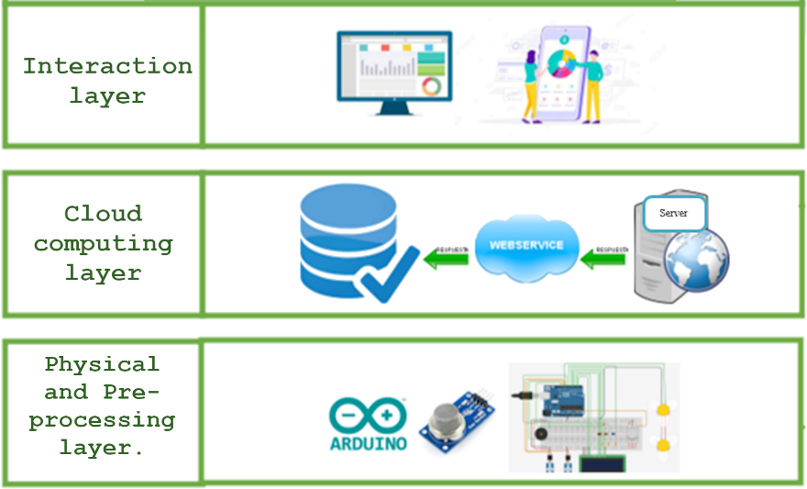
Fig. 1. IdeAir architecture
The Fig. 2 shows the design of the device (corresponding to the physical layer) to detect the level of air quality and act appropriately (according to its configuration) to alert the inhabitants of the house and watch over their health when the air quality is not adequate. This diagram was realised using the TDDT4IoTS [14]. Its components are (see Fig. 2): (1) Arduino Uno board, configured to capture the data emitted by the MQ135 and MQ7 sensors, as well as to give the commands to the actuators; (2) active buzzer, for audible notifications; (3) LEDs, for light notifications; (4) ESP3286 NodeMCU, development board to control the DHT11 sensor and for internet connectivity; (5) DHT11 sensor, to measure the temperature and humidity of the environment; (6) MQ135 sensor, to detect CO₂ , C₆ H_{6,} NH₃ and NO₂; (7) MQ7 sensor, to detect CO; (8) servomotors, to open and close the window; (9) LCD display, to report on ambient air quality; and (10) fans, to expel polluted air.
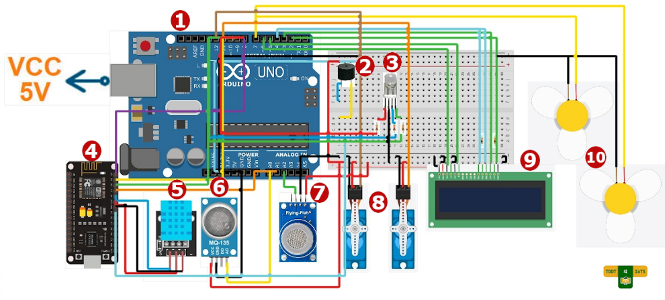
Fig. 2. IdeAir device design.

The authors of TDDM4IoTS present it as an interactive methodology. They also state that some stages will not need to be repeated for each deliverable, it will be enough to be carried out only once (in the first iteration). The Design stage of the technological layer is one of them. This was the case in the development of IdeAir. For this system there were clear and concrete requirements from the early stages. In addition, the customer's participation in this stage was decisive to ensure that the system design met the needs of customer.
It has been precisely detailed so that the reader can easily determine the final value (in his/her local market) that he/she would have to be invested in the construction of the device.

Detailed requirements analysis. For the detailed requirements analysis, we used the extended use cases [22], which were used for the detailed requirements analysis, as recommended by TDDM4IoTS [14]. Use cases have proven to be a very clear tool for collecting the functional requirements of the system as expressed by the users [23]. By doing a thorough analysis of each use case, and using TDDT4IoTS correctly, the development of an IoTS will be easier. With TDDT4IoTS the work of the developers (analysts) will concentrate on the writing of the use cases. This tool uses a language based on punctuation marks that serve to denote the different elements of object-oriented analysis, with the purpose of generating platform-independent diagrams (class diagrams) from the use cases, the tests that are considered by many developers as a waste of time, ending with the generation of the software. The generated software corresponds to the entity classes specified in the use cases, controller classes and web services based on the Spring Boot framework. Table 3 shows one of the use cases in which the system requirements specifications were documented.
Table 3. Specification of the use case to issue notifications.
Use cases: | Notification
Actors: | User, Environment
Purpose: | Report the level of ambient air quality present.
Summary: | The user is alerted to the air quality level.
Type: | Primary
Preconditions: | The user must be logged in.
Post conditions: | Notification data recorded
Normal course of events
Actor's reaction | System responses
1. This use case starts when the user starts the system.  8. This use case ends when the user shuts down the system. | 2. Detects the concentration of CO in the environment.  3. Calculate concentration levels.  4. If the concentration level is greater than 800  4.1. lights up the red light,  4.2. reproduces a constant high-pitched sound,  4.3. displays "Poor air quality" on the screen.  5. If the concentration level is between [800 and 500),  5.1. turn on the orange light,  5.2. reproduces a slow high-pitched sound,  5.3. display "Air quality low".  6. If the concentration level is between [500 and 350)  6.1. turn on the blue light,  6.2. reproduces a constant faint sound,  6.3. displays 'Moderate air quality'.  7. If the concentration level is maximum 350  7.1. turn on the green light,  7.2. turn off the sound,  7.3. displays "Air Quality Good".  9. This use case ends when the system registers the data in the database.
Alternate Flow
Actor's reaction | System responses
None
Requirements mapped out: | Issue concentration level notification.
Points of inclusion: | Data storage
Notes: | Issue notifications

Model generation, testing, and software. In these 3 phases of TDDM4IoTS, the TDDT4IoTS development tool was used [20]. This is a tool that is in its first version, and is able to generate the web application software, including its preliminary graphical user interfaces, from the use cases. It also allows the design of IoT devices and automatically generates most of the software required for their configuration and operation (currently with support for Arduino). Now, TDDT4IoTS does not generate the mobile application. Therefore, the software for the user interfaces of the IdeAir mobile app (front-end) was created by the developers in its entirety.

Regarding the web tool, TDDTIoTS uses the model-view-controller pattern to generate source code from the classes diagram. In addition, part of the business logic is transformed into classes to generate and publish the RESTful web services, which will be used to execute the basic operations or CRUD (create, read, update, delete) with the database.

Refinement and adaptation of models, test and software. During model refinement, some methods were added, such as constructors and other methods not specified in the use cases, as well as a class for specifying air quality reference levels. Therefore, the accuracy of the platform-independent model depends on the degree of detail with which the use cases are specified using a TDDT4IoTS-specific punctuation-based language.
The Fig. 2 shows part of the software architecture (the classes diagram), after being generated by TDDT4IoTS and refined for the generation and testing of the IdeAir software. The automatically generated tests were refined and adapted to the needs of the end users. Integration tests were written by the developers in the detailed requirements analysis phase and executed in the deployment to verify compliance. To test the correct functioning of the device before deployment, the environment was contaminated by generating appropriate gases, basically to test the capture and delivery of data in real time.


Fig. 2. IdeAir refined classes diagram.
In addition, some methods specified in the classes diagram had to be implemented by the developers, as their business logic could not be automatically generated in its entirety from the use cases.

Hardware and software deployment. The device of IdeAir was deployed in a mock-up of a room that simulated a real room, to prototype how the system would work. Low-power servomotors were used, which are not sufficient to drive a real window. With this proof of concept, the authors believe there is sufficient evidence to determine that this system meets the requirements set by the customer.
The web application is deployed on a server of the affiliation institution of some of the authors, within the "aplicaciones" subdomain.
On the other hand, as described above, the mobile application allows registering the IdeAir device(s) for control, monitoring data capture in real time and receiving notifications when gas levels are harmful to health, as well as performing common operations such as registering as a user, logging in and viewing information about the system. Fig. 3 shows some screenshots of the mobile application.
When the user is authenticated in the mobile application, he can access his information and options to view devices and captured data, as shown in Fig. 3(a). If you do not have registered devices, you can do so from the Device option and the screen shown in Fig. 3(b) will appear. If you have registered at least one IdeAir device, you will be able to monitor the environments in which they are installed, and you will also be able to see in real time the data that the device is capturing and sending to the server, as shown in Fig. 3(c).
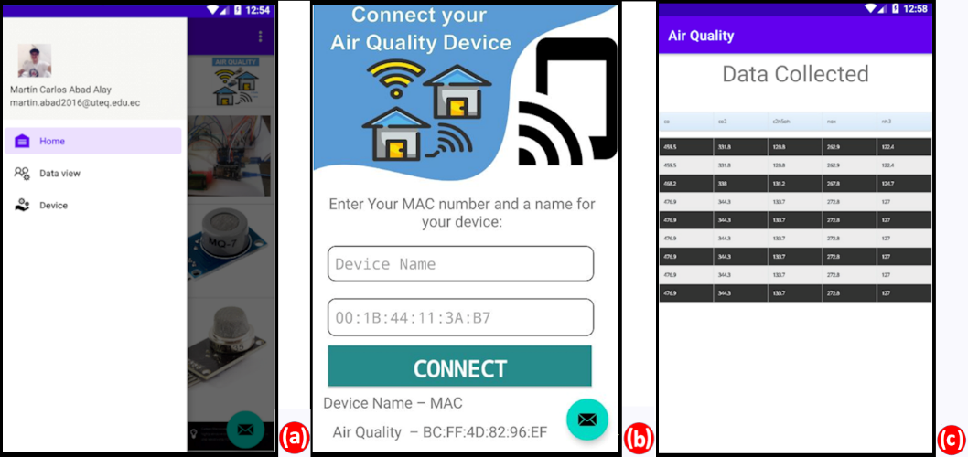
Fig. 3. Screenshots of the mobile application.
- Conclusions and future work
The implementation of a proof of concept of the IdeAir system has been presented, which makes it possible to determine the level of indoor air quality, and to act and alert people when the level of toxicity is dangerous. The use of web services and a WebHost server allows the environmental data captured by IdeAir to be known in real time. In IdeAir tests, users commented that they found it more useful to hear the alarm and see the light notifications in the room to alert them to air toxicity levels than the mobile app notifications.

Following the TDDM4IoTS methodology made developers more orderly in carrying out IoTS development activities. In addition, using the TDDT4IoTS tool helped them to be more productive. The code generated by the tool was fully utilised. In addition, it was possible to eliminate much of the time spent writing tests (a neuralgic part of the Test-Driven Development (TDD) methodology), which most developers consider "wasted time".
As another future work, after evaluating its functions as a proof of concept, a prototype of the IdeAir system will be developed and deployed to test its operation in a real home. Furthermore, IdeAir will be designed as a wireless sensor network to sense the possible gases that may be present in a house depending on the environment to be monitored. For example: in the kitchen propane and/or butane gas, in the bathroom, for the use of heaters CO and CO2, and in the living room, a device will be designed with all the benefits of the one presented in this document. Other future work we plan to further improve the TDDT4IoTS tool, especially in terms of generating more code and generating the interfaces for the mobile application for both Android and iOS.

References
- Ezeonyejiaku, C., Okoye, C., Ezeonyejiaku, N., Obiakor, M.: Air Quality in Nigerian Urban Environments: A Comprehensive Assessment of Gaseous Pollutants and Particle Concentrations, Current Applied Science Technology 22(5), (2021).
- World Health Organization: WHO Global Air Quality Guidelines. Particulate Matter (PM2.5 and PM10), Ozone, Nitrogen Dioxide, Sulfur Dioxide and Carbon Monoxide, (2021), https://apps.who.int/iris/bitstream/handle/10665/345329/9789240034228-eng.pdf, last accessed 2022/03/26.
- Rodríguez, A.: A Bad Heater Caused a Tragedy in the Comité del Pueblo. Five Members of a Family Died, El Comercio - Actualidad (Un Calefón en Mal Estado Provocó una Tragedia en el Comité del Pueblo. Cinco Miembros de una Familia Murieron, El Comercio – Actualidad), https://www.elcomercio.com/actualidad/quito/intoxicacion-monoxido-carbono-muerte-quito.html, last acceded 2022/03/17.
- Gazis A., Katsiri, E.: Smart Home IoT Sensors: Principles and Applications A Review of Low-Cost and Low-Power Solutions, International Journal on Engineering Technologies and Informatics 2(1), 2021.
- Instantaneous Heaters are the Main Cause of Carbon Monoxide Poisoning : Civil Defence (Los Calefones Instantáneos son la Principal Causa Intoxicación por Monóxido de Carbono : Defensa Civil), https://www.mendoza.gov.ar/defensacivil/noticias/los-calefones-instantaneos-son-la-principal-causa-intoxicacion-por-monoxido-de-carbono/, last accessed 2022/03/14.
- National Risk and Emergency Management Service (Servicio Nacional de Gestión de Riesgos y Emergencias): SGR Advises on the Use of Space Heaters (SGR Aconseja Sobre el Uso de Calefones), https://www.gestionderiesgos.gob.ec/sgr-aconseja-sobre-el-uso-de-calefones/, last accessed 2022/03/15.
- Bommi, R. M., Monika, V., ArockiaKoncy, A. A., Patra, C.: A Surveillance Smart System for Air Pollution Monitoring and Management. In Lecture Notes on Data Engineering and Communications Technologies, pp. 1407-1418. Springer, Cham (2019).
- Zhou, M., Abdulghani, A. M., Imran, A. M., Abbasi, Q. H.: Internet of Things (IoT) Enabled Smart Indoor Air Quality Monitoring System. In ACM International Conference Proceeding Series, pp. 89–93. ACM, New York (2020).
- Guerrero-Ulloa, G., Hornos, M. J., Rodríguez-Domínguez, C.: TDDM4IoTS: A Test-Driven Development Methodology for Internet of Things (IoT)-Based Systems, Communications in Computer and Information Science, 1193, 41–55 (2020).
- Shrestha, P. M. et al.: Impact of Outdoor Air Pollution on Indoor Air Quality in Low-Income Homes during Wildfire Seasons", Int. J. Environ. Res. Public Heal. 2019, Vol. 16, Page 3535, ISSN: 1660-4601, vol. 16, no. 19, p. 3535, Sep. 2019, DOI: 10.3390/IJERPH1619353535.
- Liu, Z., Wang, G., Zhao, L., Yang, G.: Multi-Points Indoor Air Quality Monitoring Based on Internet of Things, IEEE Access 9, 70479–70492 (2021).
- Kotsev, A., Schade, S., Craglia, M., Gerboles, M., Spinelle, L., Signorini, M.: Next Generation Air Quality Platform: Openness and Interoperability for the Internet of Things, Sensors, 16(3), 403 (2016).
- Taştan, M., Gökozan, H.: Real-Time Monitoring of Indoor Air Quality with Internet of Things-Based E-Nose, Applied Sciences (Switzerland) 9(16), 3435 (2019).
- Azma Zakaria, N., Zainal Abidin, Z., Harum, N., Chen Hau, L., Salih Ali, N., Azni Jafar, F.: Wireless Internet of Things-Based Air Quality Device for Smart Pollution Monitoring, International Journal of Advanced Computer Science and Applications (9)11, 65–69 (2018).
- Guerrero-Ulloa, G., Carvajal-Suárez, D., Brito-Casanova, G., Pachay-Espinoza, A., Hornos, J.M., Rodríguez-Domínguez, C.: Test-Driven Development Tool for IoT-based System, Aug. 2021. https://aplicaciones.uteq.edu.ec/tddm4iots/ (accessed Apr. 02, 2022).
- Usländer, T., Batz, T.: How to Analyse User Requirements for Service-Oriented Environmental Information Systems. In Advances in Information and Communication Technology, vol. 359, pp. 161–168 (2022).
- Dörr, J., Kerkow, D., von Knethen, A., Paech, B.: Eliciting Efficiency Requirements with Use Cases. In 9th International Workshop on Requirements Engineering: Foundation for Software Quality (REFSQ), vol. 8, pp. 23–32 (2003).

https://aplicaciones.uteq.edu.ec/ideair/

